Barnet federation of allotment and horticultural societies

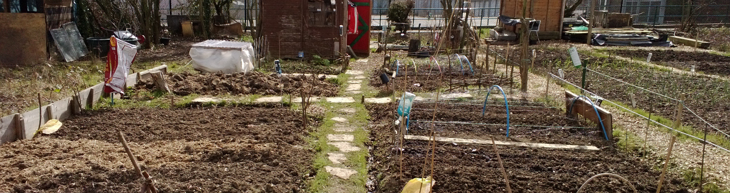

Barnet federation of allotment and horticultural societies